Admin Dashboard Interface Module
The Admin Dashboard Interface Module provides frontend screens for managing website operations.
Features
- Dashboard summary cards
- Product management UI
- Order management UI
- Consultation management UI
- Appointment management UI
- Patient list UI
- Status dropdowns
- View details buttons

admin-login.html
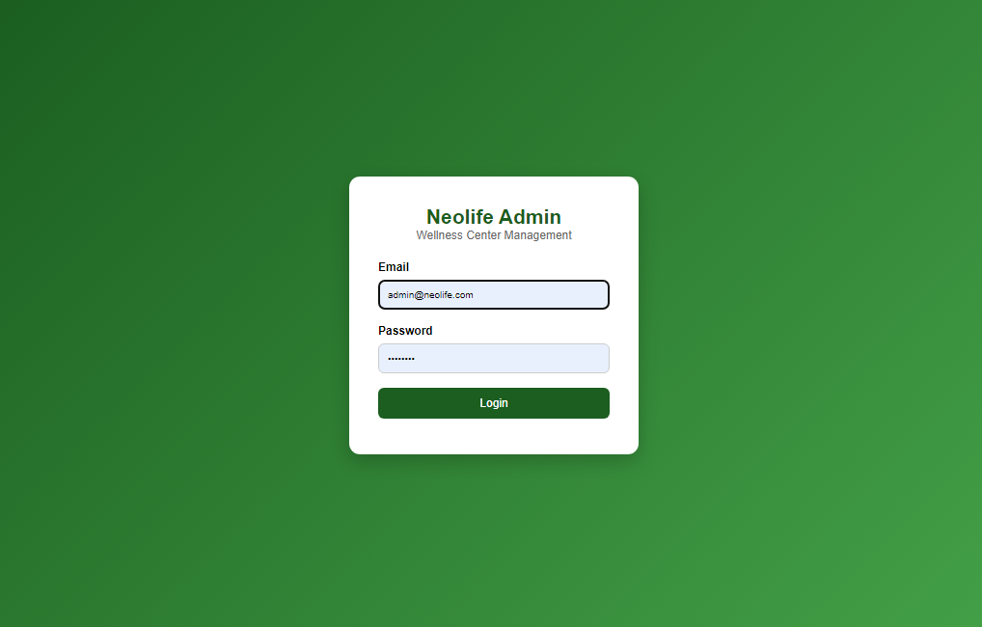

admin-dashboard.html
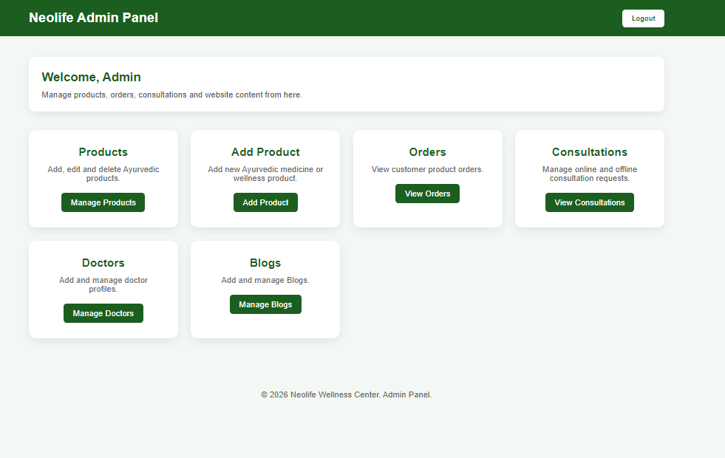

Admin Dashboard Module Documentation

Module Name
Admin Dashboard

Purpose
The Admin Dashboard acts as the central management system for Neolife Wellness Center.
Only authenticated users with ADMIN role can access this module.
It provides navigation and summary access to:
- Product Management
- Order Management
- Consultation Management
- Doctor Management
- Blog Management

admin-product.html
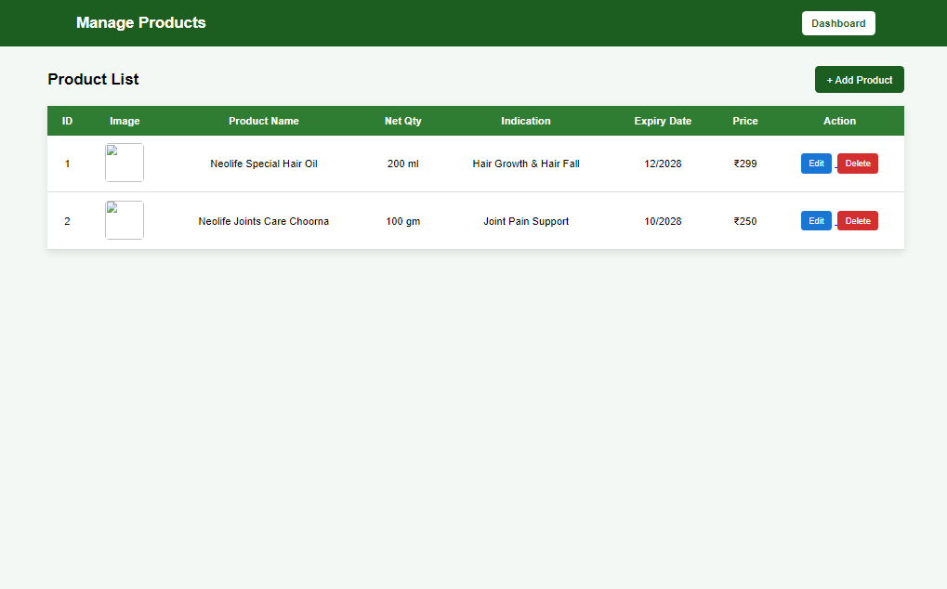

Manage Products Module Documentation

Module Name
Manage Products

Purpose
This module allows administrators to:
- View all products.
- Search products.
- Edit product details.
- Delete products.
- Navigate to Add Product page.
- Manage inventory.
Only ADMIN users should have access.

Frontend Page
admin-products.html

Features

View Product List
Displays:
- Product ID
- Product Image
- Product Name
- Net Quantity
- Indication
- Expiry Date
- Price
- Actions

edit-product.html
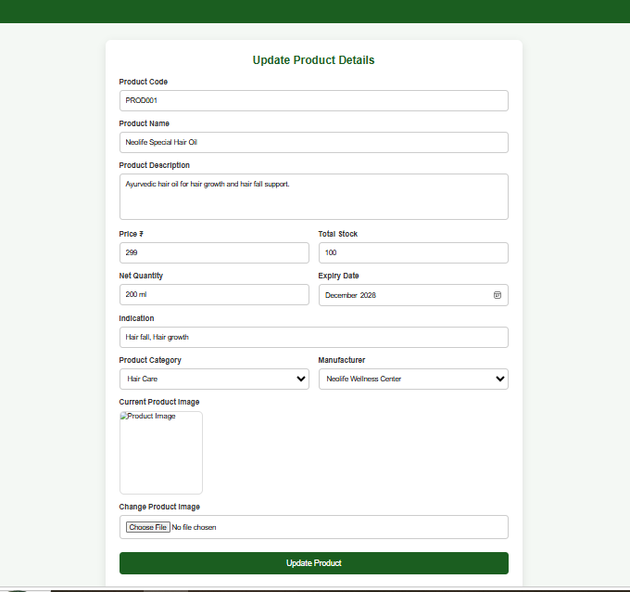
Edit Product Module Documentation
Module Name
Edit Product
Purpose
This module allows administrators to update existing product details such as price, stock quantity, category, manufacturer, image, and other information.
Only ADMIN users should have permission to edit products.

Frontend Fields
Field | Type | Required | Description
productId | Long | Yes | Internal product id
productNo | String | Yes | Unique product code
name | String | Yes | Product name
description | String | Yes | Product description
price | Decimal | Yes | Product price
stock | Integer | Yes | Available quantity
netQty | String | Yes | Net quantity
expiryDate | Date | Yes | Product expiry date
indication | String | Yes | Product indication
category | String | Yes | Product category
manufacturer | String | Yes | Manufacturer
image | File | Optional | Product image

add-product.html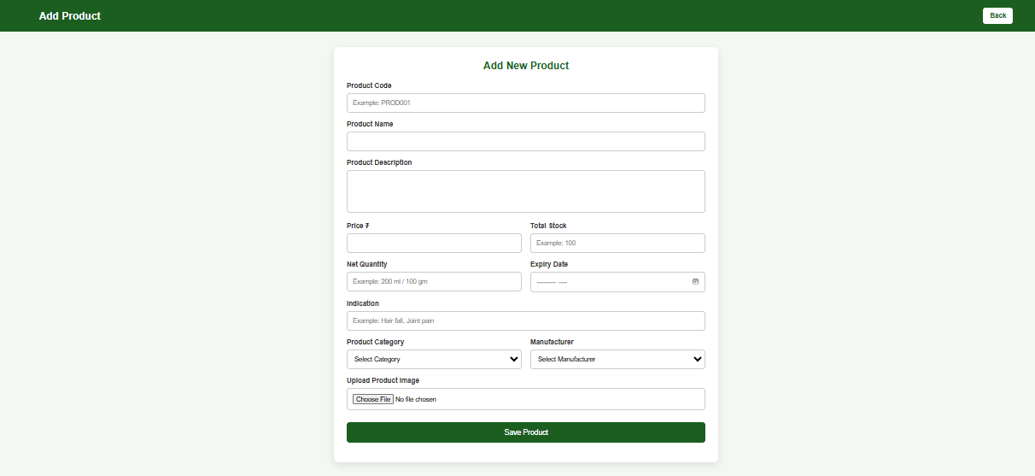

Module Name
Product Management

Purpose
This module is used to add, retrieve, update, and delete products in the Neolife Wellness Center application. It supports product inventory and e-commerce functionality.

Product Fields
Field | Type | Required | Description
productNo | String | Yes | Unique product code
name | String | Yes | Product name
description | String | Yes | Product description
price | Decimal | Yes | Product price
stock | Integer | Yes | Available quantity
netQty | String | Yes | Net quantity (200 ml, 100 gm, etc.)
expiryDate | Date | Yes | Expiry month and year
indication | String | Yes | Usage indication
category | String | Yes | Product category
manufacturer | String | Yes | Manufacturer name
imageUrl | String | Yes | Product image URL/path

admin-orders.html
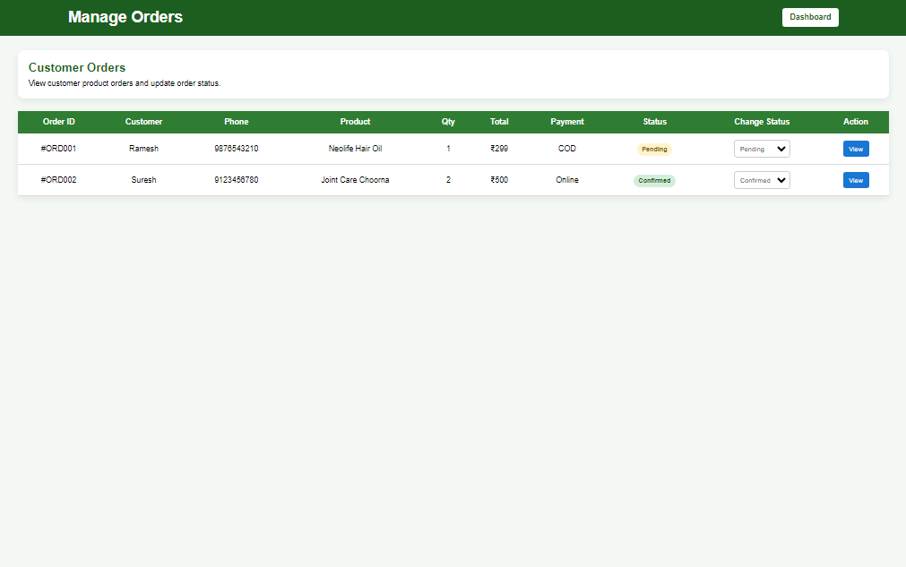

Module Name
Admin Orders Management

Purpose
This module allows administrators to:
- View all customer orders.
- View complete order details.
- Change order status.
- Track payment method.
- Manage delivery process.
Only ADMIN users can access this module.

Frontend Page
admin-orders.html

Features
View Orders
Displays:
- Order ID
- Customer Name
- Phone Number
- Product Name
- Quantity
- Total Amount
- Payment Method
- Order Status
- Change Status
- View Details

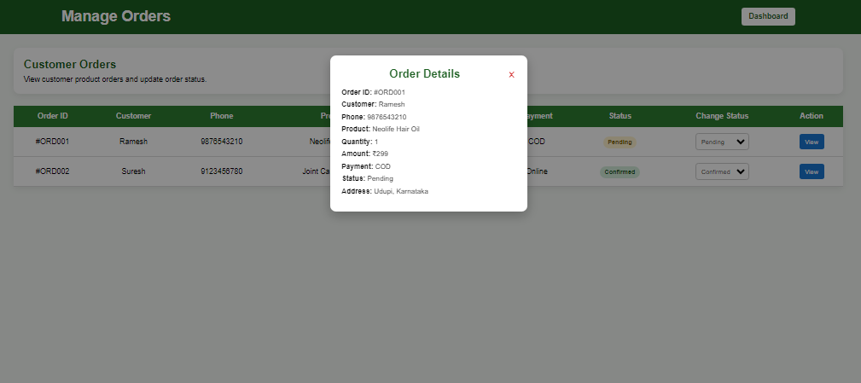
admin-consultation.html
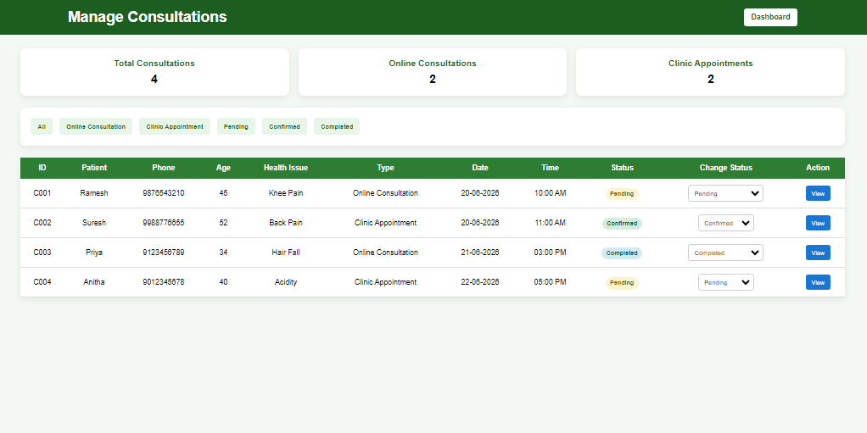 Module Name
Admin Consultation Management

Purpose
This module enables administrators to manage:
- Online Consultations
- Clinic Appointments
- Consultation Status
- Meeting Link Generation
- Patient Information
- Consultation Statistics
Only users with ADMIN role should have access.

Frontend Page
admin-consultations.html

Consultation Types
Online Consultation
Video consultation after payment.
Statuses:
Pending
Confirmed
Meeting Link Sent
Completed

Clinic Appointment
Physical visit to clinic.
Statuses:
Pending
Confirmed
Visited
Completed

Dashboard Statistics
Displays:
Total Consultations
Online Consultations
Clinic Appointments
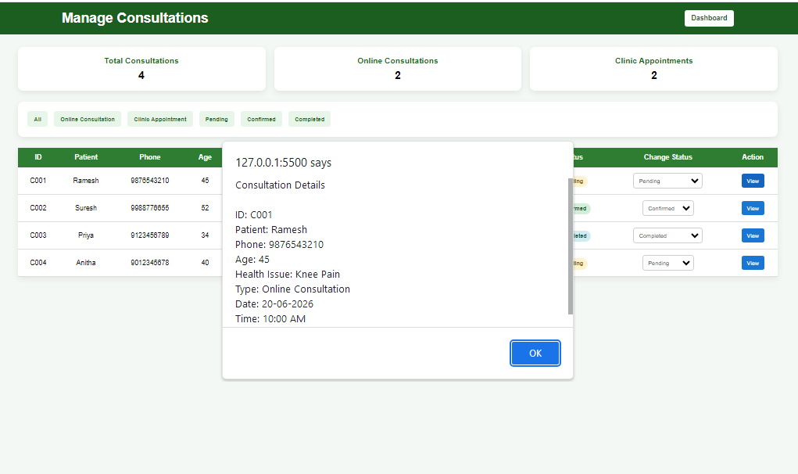 admin-doctors.html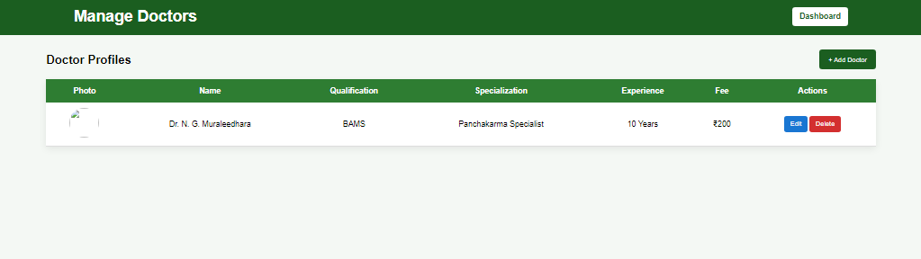 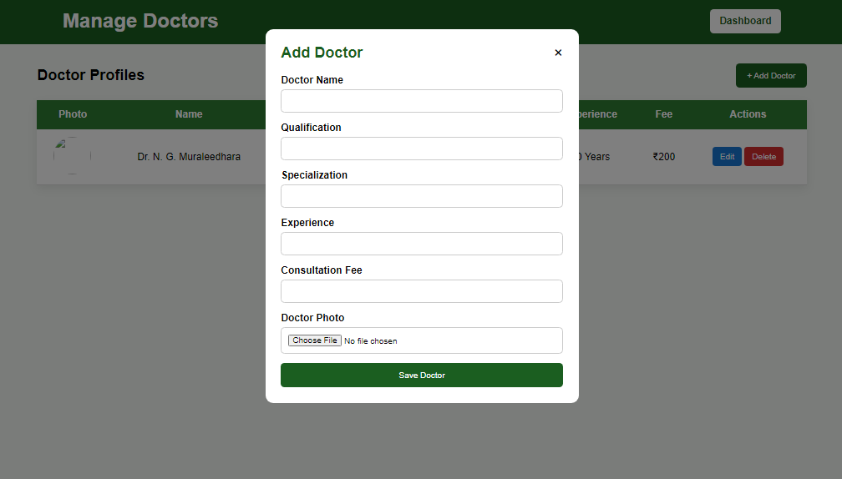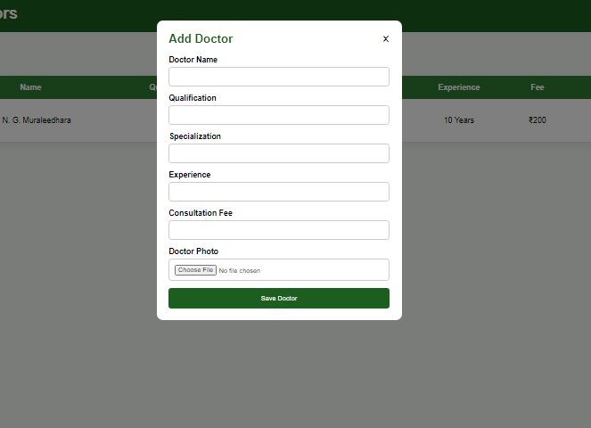

Doctor Management Module Documentation

Module Name
Doctor Management

Purpose
This module allows administrators to:
- View doctor profiles.
- Add new doctors.
- Update doctor information.
- Delete doctor profiles.
- Manage consultation fees and specializations.
- Upload doctor photographs.
Only ADMIN users should have access to this module.

Frontend Page
admin-doctors.html

Features

View Doctors
Displays:
- Doctor Photo
- Doctor Name
- Qualification
- Specialization
- Experience
- Consultation Fee
- Actions

Add Doctor
Admin can add:
- Doctor Name
- Qualification
- Specialization
- Experience
- Consultation Fee
- Doctor Photo

Edit Doctor
Admin can modify:
- Name
- Qualification
- Specialization
- Experience
- Consultation Fee

Delete Doctor
Admin can remove doctor profiles.
Confirmation popup should be displayed before deletion.
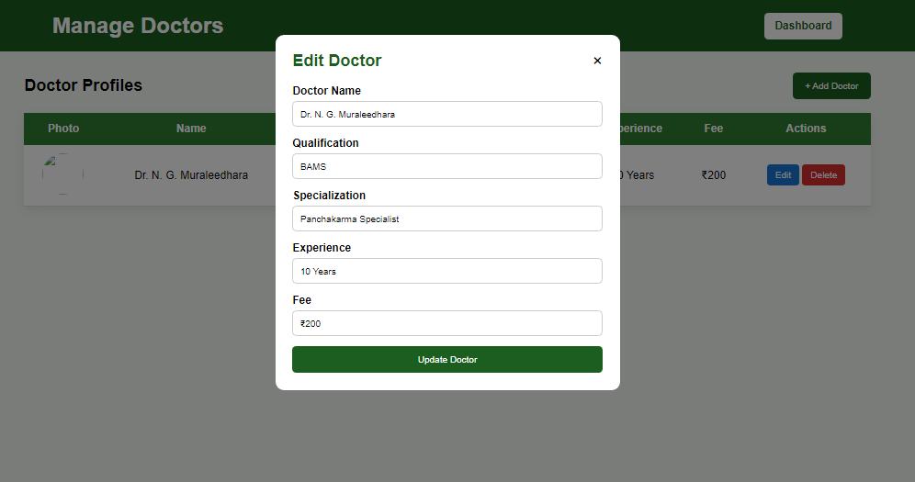

admin-blog.html

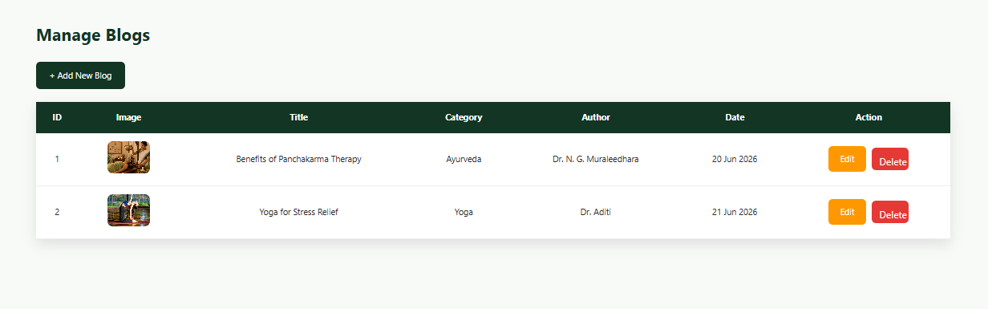

Module Name
Blog Management

Purpose
This module enables administrators to:
- View all blogs.
- Create new blogs.
- Edit existing blogs.
- Delete blogs.
- Categorize blogs.
- Display blogs on the public website.
Only users with ADMIN role should have access to blog management.

Frontend Page
admin-blogs.html

Features

View Blog List
Displays:
- Blog ID
- Blog Image
- Blog Title
- Category
- Author
- Published Date
- Edit Action
- Delete Action

Add Blog
Redirects to:
add-blog.html
Admin can enter:
- Blog Title
- Blog Category
- Author Name
- Blog Content
- Featured Image
- Publish Date

Edit Blog
Redirects to:
edit-blog.html?id={id}
Admin can modify:
- Title
- Category
- Content
- Image
- Author
- Publish Status

Delete Blog
Remove blog from database.
Confirmation popup should be shown before deletion.

add-blog.html

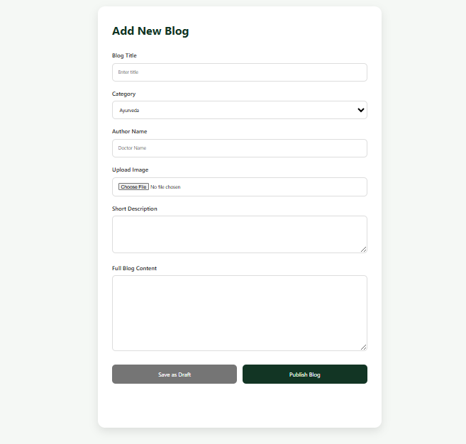

Module Name
Add Blog

Purpose
This module allows administrators to create new blogs and save blogs as drafts before publishing them to the website.
Only users with ADMIN role should have access.

Frontend Page
add-blog.html

Features

Create New Blog
Admin can enter:
- Blog Title
- Category
- Author Name
- Blog Image
- Short Description
- Full Blog Content

Save as Draft
Blog status:
DRAFT
Draft blogs are stored in database but are not visible to users.

Publish Blog
Blog status:
PUBLISHED
Published blogs become visible on:
- blog.html
- blog-details.html
- Home page blog section

Blog Categories
Supported Categories
- Ayurveda
- Yoga
- Panchakarma
- Naturopathy
- Lifestyle
Additional categories can be added later.
edit-blog.html

Module Name
Edit Blog

Purpose
This module allows administrators to update existing blog posts.
Administrators can:
- Modify blog title.
- Change category.
- Update author information.
- Replace blog image.
- Edit short description.
- Edit complete blog content.
- Save changes.
Only users with ADMIN role should have access.

Frontend Page
edit-blog.html

Features

Load Existing Blog
When admin clicks Edit from Blog List:
edit-blog.html?id=1
Frontend calls:
GET /api/blogs/{id}
and fills the form with existing blog data.

Editable Fields

Blog Title
Type:
String
Example:
Benefits of Panchakarma Therapy

Category
Supported Categories
- Ayurveda
- Yoga
- Panchakarma
- Naturopathy
- Lifestyle

Author Name
Example:
Dr. N. G. Muraleedhara

Current Image
Display existing image.

Change Image
Upload new image.

Short Description
Example:
Panchakarma is a traditional Ayurvedic detox therapy that supports body cleansing, rejuvenation and long-term wellness.

Full Blog Content
Example:
Panchakarma is one of the most important detoxification and rejuvenation therapies in Ayurveda. It helps cleanse the body, balance doshas and support natural healing.

